DA FINAL PROJECT


Survey Topic:
"Women's Legal Awareness and Access to Justice"

MG2008 – Data Analysis for Business I
BFT-2C
Miss Aroosa Safdar

Group Members:
Shaban Akhtar
Javeria Qanita
Alizay Danish
Emaan Fatima
Momina Naveed
Ibrahim Sanwal

Spring 2026
National University of Computer and Emerging Sciences

ABSTRACT
The proposed project examines the degree of legal awareness among Pakistani women, using primary data of 53 participants, an online survey. The participants were mainly students of female gender and living in Lahore and the survey involved different aspects of the legal rights in marriage, harassment, and in the justice system.

These results suggest that traditional family-related rights awareness is rather high: about 64 percent of the respondents said that they were fully aware of their Nikah rights, and about 83 percent were aware of child marriage. Nonetheless, the level of trust in the legal system is still very low, and more than 58 percent of the respondents are unlikely or very unlikely to trust the law to defend their rights.

The dataset was subjected to statistical analysis consisting of frequency tables, cross-tabulations, calculation of probabilities, test of normal distribution, and simple linear regression. The regression model revealed that there was a positive correlation between education level and legal awareness but the wide dispersion in the data indicated that there could be other factors that contributed significantly to the development of legal awareness and these may include the media exposure, social environment and income.

ACKNOWLEDGEMENT
This research would not have been possible without the respondents who provided the data through the survey. Without their time and desire to share their experiences, the project would not have been completed.

To our instructor Aroosa Safdar at the National University of Computer and Emerging Sciences out utmost gratitude for teaching us to use data analysis techniques on a real-world basis. Through her guidance throughout the semester we were able to tackle this topic.

The all the members of our group who took time to carry out the survey, compile the data, and help with the analysis and write-up of the data, Thank you. This project was a collective effort of all the members.

TABLE OF CONTENTS
Note: Front matter pages (Abstract – Abbreviations) are numbered i–v. Arabic page numbering (1, 2, 3…) begins at Section 1: Introduction.
ABSTRACT i
ACKNOWLEDGEMENT ii
TABLE OF CONTENTS iii
LIST OF TABLES iv
LIST OF FIGURES iv
LIST OF ABBREVIATIONS v
1. INTRODUCTION & LITERATURE 1
1.1 Introduction 1
1.2 Problem Statement 1
1.3 Literature Review 2
2. OBJECTIVES OF THE STUDY 3
3. DATA COLLECTION & METHODOLOGY 4
3.1 Data Source 4
3.2 Data Description 4
3.3 Variables Description 4
3.4 Type of Data 4
4. ANALYSIS & RESULTS 5
4.1 Graphical Summaries 5
4.2 Tabular Summaries 8
4.3 Numerical Analysis (Age) 10
4.4 Cross-Tabulation 12
4.5 Probability Analysis 15
4.6 Normal Distribution 16
4.7 Regression Analysis 18
5. CONCLUSION 20
6. LIMITATIONS OF THE STUDY 21
7. REFERENCES 22
8. EVIDENCE OF WORKING 23

LIST OF TABLES
Table 1: Distribution of Working Status 10
Table 2: Distribution of Education Level 10
Table 3: Distribution of Nikah Rights Awareness 11
Table 4: Distribution of Trust in Legal System 11
Table 5: Grouped Age Distribution 12
Table 6: Numerical Summary Statistics for Age 13
Table 6b: Measures of Dispersion for Age 14
Table 7: Cross-tabulation: Education Level × Nikah Rights Awareness 15
Table 8: Cross-tabulation: Education Level × Marriage Law Awareness 16
Table 9: Cross-tabulation: Age Group × Nikah Rights Awareness 17
Table 10: Cross-tabulation: Education Level × Trust in Legal System 18
Table 12: Correlation Summary 23
Table 11: Regression Coefficients Summary 25

LIST OF FIGURES
Figure 1: Distribution of Working Status 6
Figure 2: Distribution of Education Level 7
Figure 3: Awareness of Nikah Rights 7
Figure 4: Trust in the Legal System 8
Figure 5: Age Distribution of Respondents (Histogram) 9
Figure 6: Education Level vs. Legal Awareness Score (Scatter Plot) 25

LIST OF ABBREVIATIONS
IQR Interquartile Range
n Sample Size
P(A) Probability of event A
Q1, Q2, Q3 First, Second, and Third Quartile
b₀ Regression intercept (value of ŷ when x = 0)
b₁ Regression slope (change in ŷ per unit change in x)
SD Standard Deviation
ŷ Predicted value of the dependent variable
z Standardized score (z-score)

1. INTRODUCTION & LITERATURE

1.1 Introduction

The strength of legal awareness to comprehend and improve gender equality is more effective in a society such as Pakistan, which has a large proportion of women who are still susceptible to exploitation and are unaware of their legal rights. Although the constitution guarantees and the accumulation of legislation that seeks to defend women, awareness of these safeguards is still not even distributed, with much of it being concentrated to educated urban groups. This project will examine the existing legal literacy levels among women in Lahore, in terms of rights regarding marriage, workplace harassment and the justice system in general.

1.2 Problem Statement

Although various legal frameworks have been established to safeguard women and include the Protection Against Harassment of Women at the Workplace Act (2010) and the Enforcement of Women's Property Rights Act (2019), women are still deprived of justice. This is an indication that the issue does not only exist in the form of laws. The main issue arises from the problem of there being ignorance of the laws existing, and women silently tolerate injustice instead of consulting the Law. This lack of awareness is often one of the first steps that needs to be addressed to gain meaningful access to justice

1.3 Literature Review
This project is based on three significant spheres of laws that are directly connected with the life of Pakistani women.

The Protection against harassment of women in the workplace act (2010) was passed to ensure that women in formal jobs have protection against sexual harassment. It requires internal inquiry committees in organizations to be established and a formal mechanism to file complaints. Although this law exists, not many people know about it especially in informal corporate environments, as seen in our survey data.

The Enforcement of Women Property Rights Act of 2019 is a law that helps women to claim property rights without undergoing lengthy and complex legal procedures. The aim of this law was to deal with the common situation where women were informally deprived of their portion of inherited property even in cases where their rights are legally affirmed.

The family laws especially the laws relating to the Nikah Nama (marriage contract) confer rights to women which are usually unknown to women. These are the right to make conditions to the Nikah contract like the limitation of the husband to a second wife, the right to Khula (dissolution of marriage). These rights are often misinterpreted or deliberately confused in the marriage procedure.

2. OBJECTIVES OF THE STUDY
The major aims of this research are as follows:
- The research question is to determine the general nature of legal awareness among the Pakistani women in Lahore, concerning rights to do with marriage, workplace harassment and property.
- To analyze the relationship between demographic variables, especially the level of education and age and the variations in the legal awareness of respondents.
- To find out how much trust women have on the legal system and its structures, such as the police and the courts.
- To perform descriptive statistical methods, such as frequency analysis, cross-tabulation, probability, regression, to determine patterns and associations in the data.
- To make inferences that can lead to a greater knowledge of the obstacles that stop women enjoying their legal rights.

3. DATA COLLECTION & METHODOLOGY

3.1 Data Source

This study was conducted using an online survey carried out using Google Forms. Fifty-three valid responses were obtained among the women in the Lahore area in Pakistan. The questionnaire included the questions concerning age, education, employment status, and awareness of the different legal rights and issues.

3.2 Data Description
The dataset is a set of 53 respondents, in which each row is a single observation. The questionnaire contained a total of 56 questions, which involved both demographic and legal awareness questions. In the context of this report, the following key variables were chosen to analyze them: age, education level, working status, awareness level on particular legal rights and trust on the legal system. The scale of awareness was based on the three-point Likert scale, which was: Not aware, Slightly aware, and Fully aware. The table below summarizes the five major topic areas that were included in the survey.
Topic Area | Legal Rights Covered
Marriage and Nikah | Nikah Nama rights, Haq Mehr, Khula, Talaq-e-Tafweez, second marriage restrictions
Child Marriage Law | Awareness of laws prohibiting marriage below the legal age
Inheritance and Property | Rights to inherited property, enforcement of property rights
Workplace Harassment | Protections under the Harassment at the Workplace Act (2010)
Trust in Legal System | Confidence in police, courts, and legal institutions to uphold rights

3.3 Variables Description

Variable | Data Type | Scale of Measurement | Interpretation
Name | Categorical | Nominal | Used for identification or labelling a respondent
Age | Quantitative | Ratio | Numeric values providing meaningful insight like mean; ratio between values is meaningful
Education Level | Categorical | Ordinal | Data can be ranked and ordered based on education level (Matric, Intermediate, Bachelors)
Working Status | Categorical | Nominal | Data can group individuals into labels ('Student', 'Unemployed', 'Working')
Awareness Levels | Categorical | Ordinal | Data can be ranked based on the Likert scale (Not aware → Fully aware)

3.4 Type of Data
The information employed in this research is cross-sectional since it was taken at one moment of time among all the respondents. It implies that we will be able to see patterns and relationships in the dataset but not make any statements regarding how awareness can evolve over time.

4. ANALYSIS & RESULTS

4.1 Graphical Summaries
Graphs were made for the key variables in the dataset. All graphs were made using Microsoft Excel. Each figure is accompanied by an interpretation of the main patterns observed.

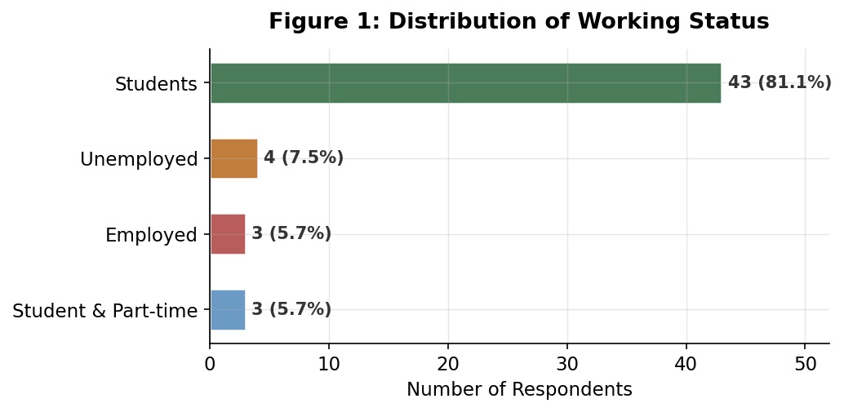
Figure 1: Distribution of Working Status
Interpretation:
The graph indicates that most of the respondents are full-time students (43/53 or 81.1). The number of those who are working, not working or studying part time is a small percentage. The results should be interpreted in the context of this heavy concentration of students. The results mostly indicate the attitudes and the level of awareness among young, academically active women and might not be representative of the general population of women.
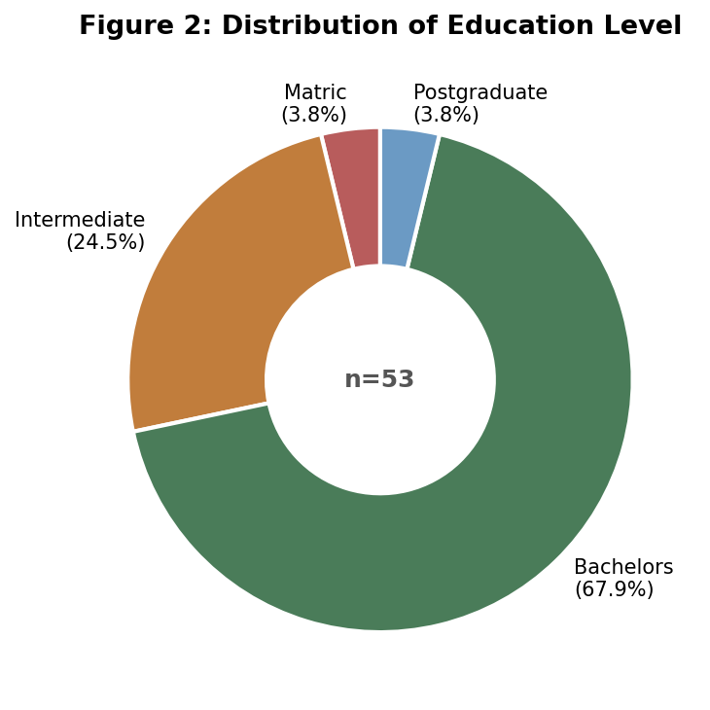
Figure 2: Distribution of Education Level
Interpretation:
The donut chart shows that a large majority of the respondents (67.9%) are in their bachelors. A significant portion (24.5%) are of intermediate education. Matric and postgraduate each have a small sample of 3.8%. With the high concentration of bachelor students we can assume that the general respondent sample is educated which contributes to the high awareness levels seen across the study. The findings should be looked at with this in mind.
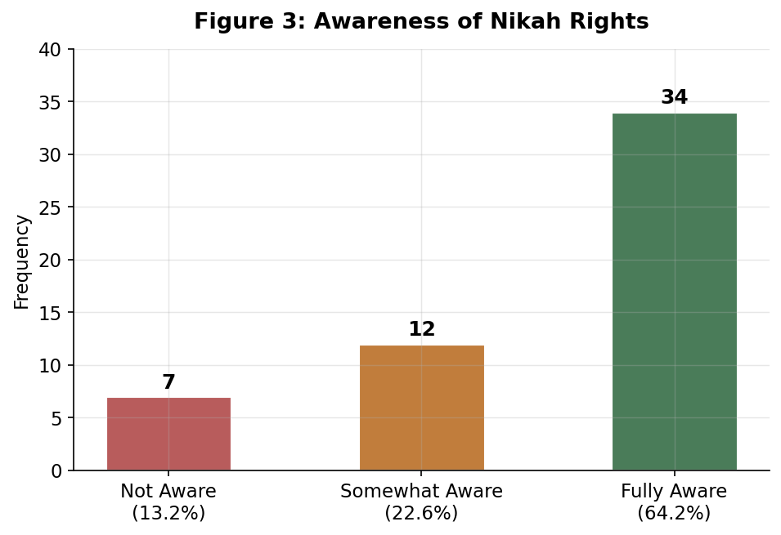
Figure 3: Awareness of Nikah Rights
Interpretation:
The bar chart shows a major portion of the respondents (64.2%) reported being fully aware of their Nikah rights, however, a significant portion of (22.6%) remain somewhat aware or not aware at all (13.2%). This gives reason to believe that while awareness is more high then not, gaps still persist, even among the educated sample.

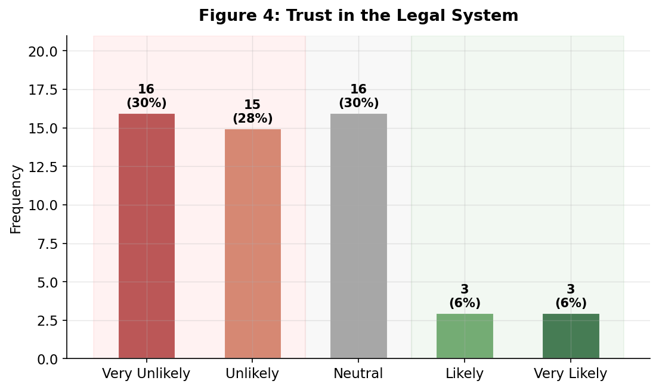
Figure 4: Trust in the Legal System
Interpretation:
The bar chart shows that there is a strong pattern of distrust in the current legal system. This is seen with a large part of the respondents (58%) being unlikely or very unlikely to trust the law, while 30.2% of them remain neutral which shows hesitance of faith in the system. Only 12% of the respondents showed trust in the system. A notable discovery was that even the respondents who were aware of their legal rights did no believe that those rights would be upheld.

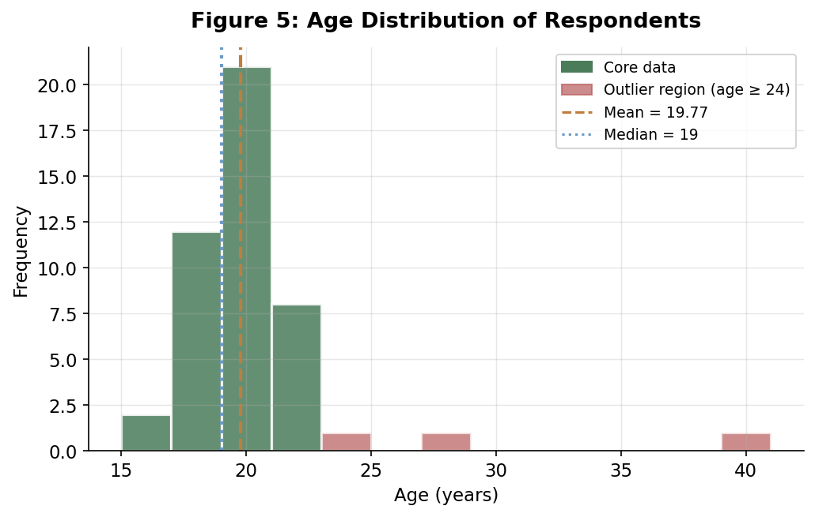
Figure 5: Age Distribution of Respondents
Interpretation:
The histogram shows us that the majority of the respondents are in the 17-21 age range. With a major concentration on ages 19 to 21, the distribution shows a long right tail which is due the few older respondents (ages of 24, 28, and 40), which have been marked in a different color. These outliers are the primary cause of the right skew. The generalization of the study is limited by the lack of older age representation in the sample.

4.2 Tabular Summaries
Construction of frequency tables was done for major variables, these tables show the frequency, relative frequency and percentage for the demographic and categorical variables.

4.2.1 Working Status
Table 1: Distribution of Working Status
Working Status | Frequency | Relative Frequency | Percent
Students | 43 | 0.811 | 81.1%
Unemployed | 4 | 0.075 | 7.5%
Employed | 3 | 0.057 | 5.7%
Student & Part-time | 3 | 0.057 | 5.7%
Total | 53 | 1.000 | 100%

A large majority of the respondents are students without jobs, which shoes that the results reflect the perspectives of young, academic women. This also means that findings regarding awareness and trust in law should be interpreted with the knowledge in mind. The views of other age and employment status groups may vary.

4.2.2 Education Level
Table 2: Distribution of Education Level
Education Level | Frequency | Relative Frequency | Percent
Matric | 2 | 0.038 | 3.8%
Intermediate | 13 | 0.245 | 24.5%
Bachelors | 36 | 0.679 | 67.9%
Postgraduate | 2 | 0.038 | 3.8%
Total | 53 | 1.000 | 100%

A significant portion of the sample consists of bachelor level education students. This reflects the bachelor program, however, this leads to under-representation of the higher and lower ends of the education system in matric, intermediate, and postgraduate. This limitation is important while considering the regression results in Section 4.7.

4.2.3 Awareness of Nikah Rights
Table 3: Awareness of Nikah Rights
Awareness Level | Frequency | Relative Frequency | Percent
Not aware | 7 | 0.132 | 13.2%
Somewhat aware | 12 | 0.226 | 22.6%
Fully aware | 34 | 0.642 | 64.2%
Total | 53 | 1.000 | 100%

It is apparent that a large majority of respondents are aware of their Nikah rights (64.2%), however, about 35.8% still have partial or no awareness at all. This stands even with the high education sample, so it can be assumed that it would be higher for the less educated samples.

4.2.4 Trust in the Legal System
Table 4: Trust in the Legal System
Trust Level | Frequency | Relative Frequency | Percent
Very unlikely | 16 | 0.302 | 30.2%
Unlikely | 15 | 0.283 | 28.3%
Neutral | 16 | 0.302 | 30.2%
Likely | 3 | 0.057 | 5.7%
Very likely | 3 | 0.057 | 5.7%
Total | 53 | 1.000 | 100%

It's seen that a large part (58%) of the respondents are in the unlikely or very unlikely category, showing distrust in the legal system. A significant portion of 30.2% are also in the neutral category, which shows uncertainty rather than confidence; only a small portion of 11.4 have expressed confidence in the system. This widespread skepticism is a major finding as it questions whether awareness alone is sufficient to improve women's access to justice.

4.2.5 Age Distribution (Grouped)
Table 5: Grouped Age Distribution
Age Group | Frequency | Relative Frequency | Percent
16 – 18 | 16 | 0.302 | 30.2%
19 – 21 | 29 | 0.547 | 54.7%
22 and above | 8 | 0.151 | 15.1%
Total | 53 | 1.000 | 100%

The table shows that about 85% of respondents are between 16 and 21, with 19 to 21 being the larges group and being the typical age of an undergraduate university student. The other 15% are those who are above 22 which includes the employed, postgraduate, or bachelor students in their final years, and significantly older individuals who are seen as the outliers.

4.3 Numerical Analysis (Age)
Numerical descriptive statistics were computed for the quantitative variable, age. These measures summarize the central tendency, dispersion, and shape of the age distribution.

Measures of Central Tendency
Table 6: Numerical Summary Statistics for Age
Measure | Value | Interpretation
Mean | 19.77 | Average age across all 53 respondents
Median | 19 | Middle value when ages are sorted; 50% are below this
Mode | 19 | Most frequently occurring age in the dataset

The mean, median, and mode all being close the 19 shows the age distribution is very close to this value. The mean being 19.77, a bit higher than the mode and median, is due to the few older respondents pulling it upwards.

Measures of Dispersion
Table 6b: Measures of Dispersion for Age
Measure | Value | Interpretation
Variance | 12.10 | Average squared deviation from the mean; inflated by outliers
Standard Deviation (SD) | 3.48 | Typical distance from the mean; most ages fall within ~3.5 years of 19.77
Interquartile Range (IQR) | 2 | Spread of the middle 50%; ages 18–20 cover the central half of respondents
Q1 (25th percentile) | 18 | 25% of respondents are aged 18 or below
Q2 / Median | 19 | 50% of respondents are aged 19 or below
Q3 (75th percentile) | 20 | 75% of respondents are aged 20 or below

The standard deviation of 3.48 implies that the majority of the respondents were between about 3.5 years of the mean. The IQR of 2 years is especially indicative: the median 50% of all respondents is between the ages of 18 and 20. This is a very small sample and this confirms that the sample is dominated by late-teen to early-twenties students. The variance of 12.10 is a rather small one but is artificially exaggerated by the outliers.

Outlier Detection Using the IQR method: Lower Bound = Q1 − 1.5 × IQR = 18 − 3 = 15. Upper Bound = Q3 + 1.5 × IQR = 20 + 3 = 23. An outlier is any age that is below 15 or above 23 years.

Identified outliers are 24, 28, and 40. These three respondents are much older than the others in the sample. In particular, the 40-year-old respondent is a very large outlier with z = 5.81, which is above the Z = -4.00. These values can slightly inflate the mean, and are the major cause of the skew to the right in the histogram. They do not discredit the data but must be taken into consideration when making generalizations of the findings.

Shape of Distribution The age distribution is skewed to the right as indicated by the histogram shown in Figure 5. This is verified by the fact that the mean (19.77) is more than the median (19) and by the outliers on the right side of the distribution. The value of skewness of 4.17 (calculated in Excel) is much higher than the standard value of 1.0 that is normally considered to be high. The distribution is not based on a normal bell-shaped curve as discussed in more detail in Section 4.6.

4.4 Cross-Tabulation
Cross-tabulations were produced to examine the relationship between demographic variables and legal awareness. Each table is followed by an interpretation of the key patterns observed.

4.4.1 Education Level and Awareness of Nikah Rights
Table 7: Cross-tabulation: Education Level × Nikah Rights Awareness
Education Level | Not Aware | Somewhat Aware | Fully Aware | Total
Matric | 1 | 1 | 0 | 2
Intermediate | 1 | 4 | 8 | 13
Bachelors | 4 | 7 | 25 | 36
Postgraduate | 1 | 0 | 1 | 2
Total | 7 | 12 | 34 | 53

The table indicates an overall positive relationship between the education level and the Nikah rights awareness. Of the intermediate respondents, 61.5% are fully aware (8 out of 13), increasing to 69.4% of those responding at the bachelor level (25 out of 36). The Matric group displays no fully conscious respondents, but the group is too small to make definite conclusions out of (n=2). In general, it seems that higher education is related to higher awareness, which correlates with the regression results in Section 4.7, but the association is not uniformly high across all groups.

4.4.2 Education Level and Awareness of Marriage Law
Table 8: Cross-tabulation: Education Level × Marriage Law Awareness
Education Level | Not Aware | Somewhat Aware | Fully Aware | Total
Matric | 1 | 0 | 1 | 2
Intermediate | 0 | 2 | 11 | 13
Bachelors | 0 | 5 | 31 | 36
Postgraduate | 0 | 1 | 1 | 2
Total | 1 | 8 | 44 | 53

Knowledge of child marriage law is significantly more strongly developed than is knowledge of Nikah rights at all levels of education: 83% of the total sample is well aware. With intermediate respondents, the percentage of fully aware is 84.6% (11 out of 13) and increases to 86.1% with bachelor-level respondents (31 out of 36). This might reflect the reality that child marriage legislations have a wider publicity and media coverage. The one respondent who is never aware is a member of Matric group, which is consistent with the fact that the exposure to legal information at the latter level is not so high.

4.4.3 Age Group and Awareness of Nikah Rights
Note: The column totals here in this table (16/20/17) are not equal to Table 3 (7/12/34) in that partially aware responses were grouped differently in the creation of such a cross-tabulation. Throughout, the sample size is n = 53.

Table 9: Cross-tabulation: Age Group × Nikah Rights Awareness
Age Group | Not Aware | Somewhat Aware | Fully Aware | Total
16 – 18 | 7 | 6 | 3 | 16
19 – 21 | 7 | 12 | 10 | 29
22 and above | 2 | 2 | 4 | 8
Total | 16 | 20 | 17 | 53

Age pattern is less evident as compared to education pattern. The youngest group (16–18) shows the lowest rate of full awareness at 18.8% (3 out of 16), the 19–21 group sits in the middle at 34.5% (10 out of 29), and the oldest group (22+) shows the highest at 50% (4 out of 8). The weaker relationship than education indicates that age alone does not have as significant an impact on legal awareness in this sample as would formal education. The small sample size of 22+ (n=8) restricts definite conclusions of that group.

4.4.4 Education Level and Trust in Legal System
Table 10: Cross-tabulation: Education Level × Trust in Legal System
Education Level | Very Unlikely | Unlikely | Neutral | Likely | Very Likely | Total
Matric | 0 | 0 | 2 | 0 | 0 | 2
Intermediate | 4 | 6 | 1 | 0 | 2 | 13
Bachelors | 11 | 9 | 13 | 2 | 1 | 36
Postgraduate | 1 | 0 | 0 | 1 | 0 | 2
Total | 16 | 15 | 16 | 3 | 3 | 53

The most striking observation of the cross-tabulations is that distrust of the legal system is always high and remains high regardless of the level of education. Among middle-level respondents, 76.9% fall into the distrust categories (Very Unlikely or Unlikely), and even among bachelor-level respondents, 55.6% fall into the distrust categories (Very Unlikely or Unlikely), and even among respondents of bachelors degree, 8.3% express any confidence (Likely or Very Likely). This implies that education has the potential to raise legal awareness but does not always lead to trust in legal institutions. More important factors are probably personal experiences with the legal system or the perception of institutional inefficiency.

4.5 Probability Analysis
Frequency data in the survey were used to determine the probability calculations. Basic, conditional and joint probabilities were calculated to measure the probability of different outcomes in the sample.

4.5.1 Basic Probabilities

P(Fully aware of Nikah rights) = 34/53 = 0.642 ≈ 64.2%

The actual probability, that a randomly selected respondent of the sample is fully aware of their Nikah rights, is about 64%. This is a measure of that fairly elevated but half-conscious awareness of this educated group.

P(Fully aware of marriage law) = 44/53 = 0.830 ≈ 83.0%

More likely at 83% is the likelihood of a respondent being fully aware of the child marriage laws. It indicates that more popular legal issues are more comprehensible, presumably because of a greater amount of media attention and the general discussion involving child marriage in
Pakistan.

P(Unlikely/Very unlikely to trust law) = 31/53 = 0.585 ≈ 58.5%

Over half of a total of responses believe they do not trust the legal system. It is a notable number that underlines one of the biggest obstacles that exist between the knowledge of the law and the actual legal access.

4.5.2 Conditional Probabilities

P(Fully aware of Nikah | Bachelors) = 25/36 = 0.694 ≈ 69.4% [Multiplication Rule]

Among respondents of a bachelor degree, the likelyhood of being totally aware of the rights of Nikah is approximately 69.4% which is much higher than the overall sample rate of 64.2. This gives credence to the notion in that more education presents that one is more aware, but the variance is not striking.

P(Fully aware of Nikah | Age 22+) = 4/8 = 0.500 ≈ 50.0% [Conditional Probability]

The likelihood of full awareness is fifty percent among the respondents who are aged 22 years and above. The fact that this was a relatively small group (n=8) is an indicator that one should be cautious with this figure, but it does indicate that older respondents may not necessarily be more aware of things due to the possibility that some of them are less formal in their education.

P(Fully aware of Nikah | Aware of marriage law) = 30/44 = 0.682 ≈ 68.2% [Conditional Probability]

When fully aware of laws regarding child marriage the chance that the respondent would also be fully aware of laws regarding Nikah rights is 68.2 per cent, slightly higher than the overall rate. This implies that various forms of legal awareness are likely to co-exist and hence, some respondents have an overall higher level of legal knowledge across the topics.

4.5.3 Addition Rule

P(Fully aware of Nikah OR Fully aware of Marriage Law) [Addition Rule]

34/53 + 44/53 − 30/53 = 48/53 ≈ 0.906 ≈ 90.6%. This means approximately 90.6% of respondents are fully aware of at least one of these two legal topics. The addition rule is applied here because the two events are not mutually exclusive: a respondent can be fully aware of both simultaneously. P(A∩B) = 30/53 is taken from cross-referencing the two awareness variables in the dataset.

4.5.4 Joint Probability

P(Fully aware of Nikah AND Fully aware of Marriage Law) = 30/53 ≈ 0.566 ≈ 56.6% [Joint Probability / Multiplication Rule]

There is approximately a 56.6% probability that a randomly selected respondent is fully aware of both their Nikah rights and child marriage laws simultaneously. This is computed by cross-referencing the two awareness variables in the dataset (30 respondents satisfied both conditions). The multiplication rule for independent events would give P(Nikah) × P(Marriage Law) = 0.642 × 0.830 = 0.533. The actual joint probability of 0.566 is slightly higher, suggesting a modest positive association between awareness of the two legal topics.

4.6 Normal Distribution (Age)
Prior to undergoing the more detailed analysis, a consideration on whether the age, which is the predominant quantitative variable in this dataset, is normally distributed or not is essential. When it does, then the normal instruments of statistics are in place. Otherwise this must be taken into consideration in the interpretation of results.

We tested normality to determine the histogram as well as to determine the z-score in a bid to establish extreme values. The most important descriptive statistics of age, which are used throughout this section are: n = 53, Mean = 19.77, Standard Deviation = 3.48 Minimum = 16 Maximum = 40.

Its average age is nearly less than 20 years and the majority of the respondents are very close to 20 years. The upper age limit of 40 is far away on one side of the data, and is at once an indication that the distribution is not going to be symmetrical.

The Histogram

The histogram in Figure 5 speaks volumes. These bars close in with the 17-20 range and then graphically decline off the cliff face, with a slender tail extending off to the right. The appearance of a normal distribution would be symmetric and in the shape of a bell, and the mass would be evenly distributed on either side of the mean. It is non-symmetrical in this distribution. It is skewed to the left, and has a slender tapered tail to the right, which is an indicator that the data is not normally distributed.

Z-Scores and Outliers
Z-scores normalize all ages, making a respondent lie a certain number of standard deviations above or below the mean. The severest example is the case of the 40-year-old respondent:

z(40) = (40 − 19.77) / 3.48 ≈ 5.81

The textbook considers anything further than ±3 times the standard deviation to be an outlier. The Z score of 5.81 is too extreme. With a real normal distribution, the likelihood of our being this far off the mean is in effect zero. This single observation alone is sufficient to rule out normality. Likewise, the age-28 respondent with z-scores of about 2.36 and 1.22 has well-into-outlier z-scores in two instances.

Conclusion on Normality
The data on age in this sample is not normally distributed. There is no doubt or contradiction to the evidence:

- The histogram, in contrast to being bell-shaped, is right skewed.
- The fact that the oldest respondent has a z-score of 5.81 proves an extreme outlier.

This makes simple sense following the sample make-up, mostly undergraduate-aged females, with a few older respondents appended as outliers. This distribution indicates who was surveyed and not a weakness in the data collection.

4.7 Correlation Analysis
To check the linear relationship between the level of education and the composite awareness score, a Pearson correlation coefficient was estimated before running the regression model. The correlation coefficient (r = 0.224) shows that there is a weak positive relationship between the two variables: the higher the education level, the higher the score on legal awareness. This agrees with the direction that the regression slope has but it affirms that the relationship is not strong. To provide a point of reference, the correlation coefficient of age and awareness score was calculated as r = -0.059 and indicates that virtually there is no linear relationship between age and awareness score in this sample. These correlation figures justify the choice of the level of education as the first predictor in the regression model.

Table 12: Correlation Summary
Variable Pair | Pearson r | Interpretation
Education Level vs. Awareness Score | 0.224 | Weak positive
Age vs. Awareness Score | −0.059 | Negligible

4.8 Regression Analysis
Simple linear regression was employed to test the hypothesis as to whether level of education can predict legal awareness. The model of regression uses the education level as the independent variable (X) and a composite score of awareness as the dependent variable (Y).

Variable Construction
Awareness Score (Y): The eight awareness-related questions within the survey, which covered such topics as Haq Mehr, child marriage law, Talaq-e-Tafweez, laws concerning workplace harassment, and protection orders. All responses were coded based on a 0-2 scale (0= Not aware, 1= Slightly aware, 2= Fully aware). These were added up to give one score out of 16 between 0 to 16 in which higher degrees imply higher overall legal awareness.

Education Level (X): Coded as an ordinal numeric scale: 1 = Matric, 2 = Intermediate, 3 = Bachelors, 4 = postgraduate, treating each step up in education as an equal increment.

The Regression Model
The standard simple linear regression equation (Anderson et al., 2011) is: ŷ = b₀ + b₁x. Running this regression in Excel (using the Data Analysis ToolPak → Regression function) produced the following result. Excel applies the Least Squares Method (Anderson et al., 2011, Ch. 14.2) to find the values of b₀ and b₁ that minimize the sum of squared differences between the observed and predicted y values:

ŷ = 7.37 + 0.99 × (Education Level)

Table 11: Regression Coefficients Summary
Coefficient | Value | Meaning
b₀ (Intercept) | 7.37 | Predicted awareness score for education level 1 (Matric); baseline estimate
b₁ (Slope) | 0.99 | Each one-step increase in education level adds ~1 point to the predicted awareness score

The coefficients are shown in Table 11 below. The intercept (b₀ = 7.37) is the predicted awareness score for a respondent at education level 1 (Matric). The slope (b₁ = 0.99) means that for each step up in education level, the predicted awareness score increases by approximately 1 point on the 16-point scale. The direction of the relationship is positive, which is what we would expect: more education is associated with slightly greater legal awareness.

Interpretation of Results

The regression is limited by the heavy concentration of respondents at the Bachelors level, with very few at the Matric or postgraduate extremes. This limits the model's ability to detect a clear trend across the full educational range.

Scatter Plot

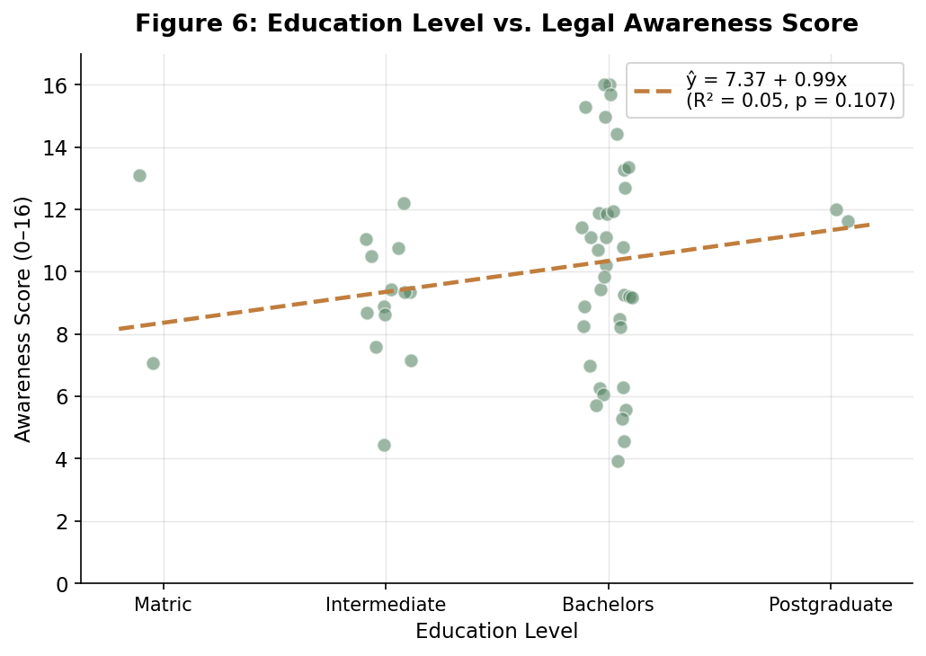
Figure 6: Education Level vs. Legal Awareness Score
The scatter plot indicates that the regression line is upwards-trending and visualizes the positive correlation between education and awareness. Nevertheless, the fact that there are numerous data points surrounding the line indicates that there are a large number of respondents within the same education level that have very different awareness scores. This implies that education in itself is not sufficient to explain legal awareness in this sample.

5. CONCLUSION
This study analyzed legal awareness among Lahore women in Pakistan, through survey data of 53 respondents. The results have shown a mixed picture: some legal rights are fairly well read among people whereas there are severe loopholes in the rest and trust of the legal system is also very low.

Regarding awareness, about 64% of those surveyed were well-informed about their Nikah rights, and 83% educated about the child marriage laws, both fairly high averages. Nevertheless, these figures should be viewed against a background of a sample which consists mostly of bachelors students in a city environment. The cross-tabulation test revealed that higher education is mostly correlated to awareness, but not always with a strong correlation across all the topics of law. The first is that age was less consistently and significantly interrelated with awareness as compared to education which does not mean all the women that study have more importance than the age of women does.

Regression analysis revealed that education insignificantly impacts the awareness scores, with a positive slope of 0.99 per level of education (slope). Nonetheless, the broad distribution of scores across all levels of education indicates that there are other intervening variables such as media exposure, social networks, income and personal experiences that also significantly influence the process of developing legal awareness.

The most remarkable result is the distrust of the legal system that becomes extremely extensive. More than 58% of the respondents were not convinced or were unlikely to be convinced that the law safeguards their rights. Even the most educated respondents continue to have this lack of trust, which means that a legal awareness alone should not suffice; women must trust the system will indeed do what they want before they can even consider it legal. This is one of the fundamental issues of justice that cannot be answered by education or sensitization campaigns.

6. LIMITATIONS OF THE STUDY
When conducting the interpretations of the findings of this study, the following limitations must be taken into consideration:

- The sample is not very large (n = 53). The findings might not be statistically representative and so caution should be taken in generalizing the results to the general female population.
- The sample is majority students (81.1), indicating that the findings are biased to a more or less agreeable view of young and academically enrolled women. Women of lower educational background and employed women are underrepresented.
- The survey was done only once, and we can not say anything regarding time-related changes in the level of awareness or trust. A longitudinal research would be required in order to follow trends.
- Self-administered surveys are susceptible to biases in responding. Respondents can give incorrect answers owing to overestimating their knowledge of the law, responding according to what they think is acceptable in society or fail to interpret what was asked
- The survey was only carried out in Lahore, a metropolitan city. The results are not necessarily representative of the situation in rural or semi-urban areas where legal awareness and access to information can be significantly less.
- We could not gather sufficient responses of lowly-educated (Matric) and highly-educated (Masters and above) women. This evokes a poor state of the regression analysis and hampers comparison across the tiers of education.
- Education level was an ordinal rank and numerically considered in regression model. This is based on the assumption of equal intervals between the levels of education which is a simplifying assumption that might not be true in reality.
- Self-reported familiarity with the conceptualization of the law is the focus of the awareness questions in the survey, not the law knowledge or the capacity to apply the law to real-life situations. It is possible that the respondents would consider that they know without any knowledge of what the laws relate to.
- Some of the variables that may have played a crucial role in legal perception e.g. income, media exposure, marriage or single status and past experiences with the legal system were omitted in the analysis. This could be supported by the fact that their omission could also be the reason behind the limitation of explanatory power of education in the regression model.
- The distribution of ages is very skewed towards the right with majority of the respondents being between 17 and 21. This complicates the recognition of age differences in the aspects of awareness, since older age groups are underrepresented.

7. REFERENCES
Anderson, D. R., Sweeney, D. J., & Williams, T. A. (2011). Statistics for Business and Economics (11th ed.). South-Western Cengage Learning.

Government of Pakistan. (2010). Protection Against Harassment of Women at the Workplace Act. National Assembly of Pakistan.

Government of Pakistan. (2019). Enforcement of Women's Property Rights Act. National Assembly of Pakistan.

Women’s Legal Awareness Study Group. (2026). Survey data on women’s legal awareness and access to justice [Raw data]. Google Forms, National University of Computer and Emerging Sciences, Lahore, Pakistan.

8. EVIDENCE OF WORKING
This section contains the supporting evidence that demonstrates how the research was conducted. It includes photographic evidence of data collection, the original questionnaire used in the survey, and five sample responses from the dataset.

8A: Evidence of Data Collection
The data for this study was collected mainly through WhatsApp, which the following images provide evidence off.

Figure 7: Google Forms Response Summary
The image shows that a total of 53 responses were collected for the study.



Figure 8: Distribution of Questionnaire via WhatsApp
The image shows the questionnaire being shared with participants through WhatsApp.


Figure 9: Distribution of Questionnaire via WhatsApp

The image shows the questionnaire being shared with participants through WhatsApp.

8B: Specimen of Questionnaire
The full questionnaire is too long to be attached in this document, so the Google Form link is provided through which the would questionnaire can be accessed.
Link: https://docs.google.com/forms/d/1WxPrYCDT9WIeOrsW-aZZB7K7c_yn6qv9Gs0q-Ahcu2I/edit?ts=69f07b1f

8C: Sample of 5 Filled Questionnaires

Response 1
Variable | Value
Age | 20
Education | Bachelors
Working Status | Student
Awareness (Nikah Rights) | Fully aware
Awareness (Child Marriage Law) | Fully aware
Trust in Law | Neutral
Likelihood to Call Helpline | Very Likely
Trust in Police Action | Unlikely

Response 2
Variable | Value
Age | 22
Education | Bachelors
Working Status | Student
Awareness (Nikah Rights) | Not aware
Awareness (Child Marriage Law) | Fully aware
Trust in Law | Neutral
Likelihood to Call Helpline | Neutral
Trust in Police Action | Very Unlikely

Response 3
Variable | Value
Age | 21
Education | Bachelors
Working Status | Student
Awareness (Nikah Rights) | Somewhat aware
Awareness (Child Marriage Law) | Fully aware
Trust in Law | Unlikely
Likelihood to Call Helpline | Neutral
Trust in Police Action | Very Unlikely

Response 4
Variable | Value
Age | 19
Education | Intermediate
Working Status | Student
Awareness (Nikah Rights) | Fully aware
Awareness (Child Marriage Law) | Fully aware
Trust in Law | Very Unlikely
Likelihood to Call Helpline | Likely
Trust in Police Action | Unlikely

Response 5
Variable | Value
Age | 23
Education | Bachelors
Working Status | Student
Awareness (Nikah Rights) | Fully aware
Awareness (Child Marriage Law) | Fully aware
Trust in Law | Neutral
Likelihood to Call Helpline | Very Likely
Trust in Police Action | Neutral

